**System-User Manual**

**Version 1.0**

**Project Management App**

**Team A**

**CSC-355**

**Spring 2016**



04/13/2016

Author: Jennifer Li – Project Leader

Submitted To: Dr. Joo Tan

**TABLE OF CONTENTS**

Revision History…………………………………………………………………………………..ii

1.0 Pre-Installation Requirements …..…..…..………….…...…………………………….……....1

2.0 Installation ………………...…..……………………………………………………………1-5

3.0

**REVISION HISTORY**

|  |  |  |  |
| --- | --- | --- | --- |
| Version | Author | Description | Date |
| 1.0 | Jennifer Li | I created the first draft. | 01/31/2016 |
|  | Jennifer Li | Added Section 1 and 2 | 04/07/2016 – 04/10/2016 |
|  |  |  |  |

**1.0 PRE-INSTALLATION REQUIREMENTS**

Before installation of the Project Management app can begin, verify the following prerequisites are met:

1. System must run on Android
2. Must have a Google Play Account to utilize the Google Play Store

**2.0 INSTALLATION**

The following directions is an easy four step guide of how to install Team A’s Project Management application using an Android device.

**Step 1.** On your Android device click the Play Store icon to enter the Google Play Store as shown in image 1

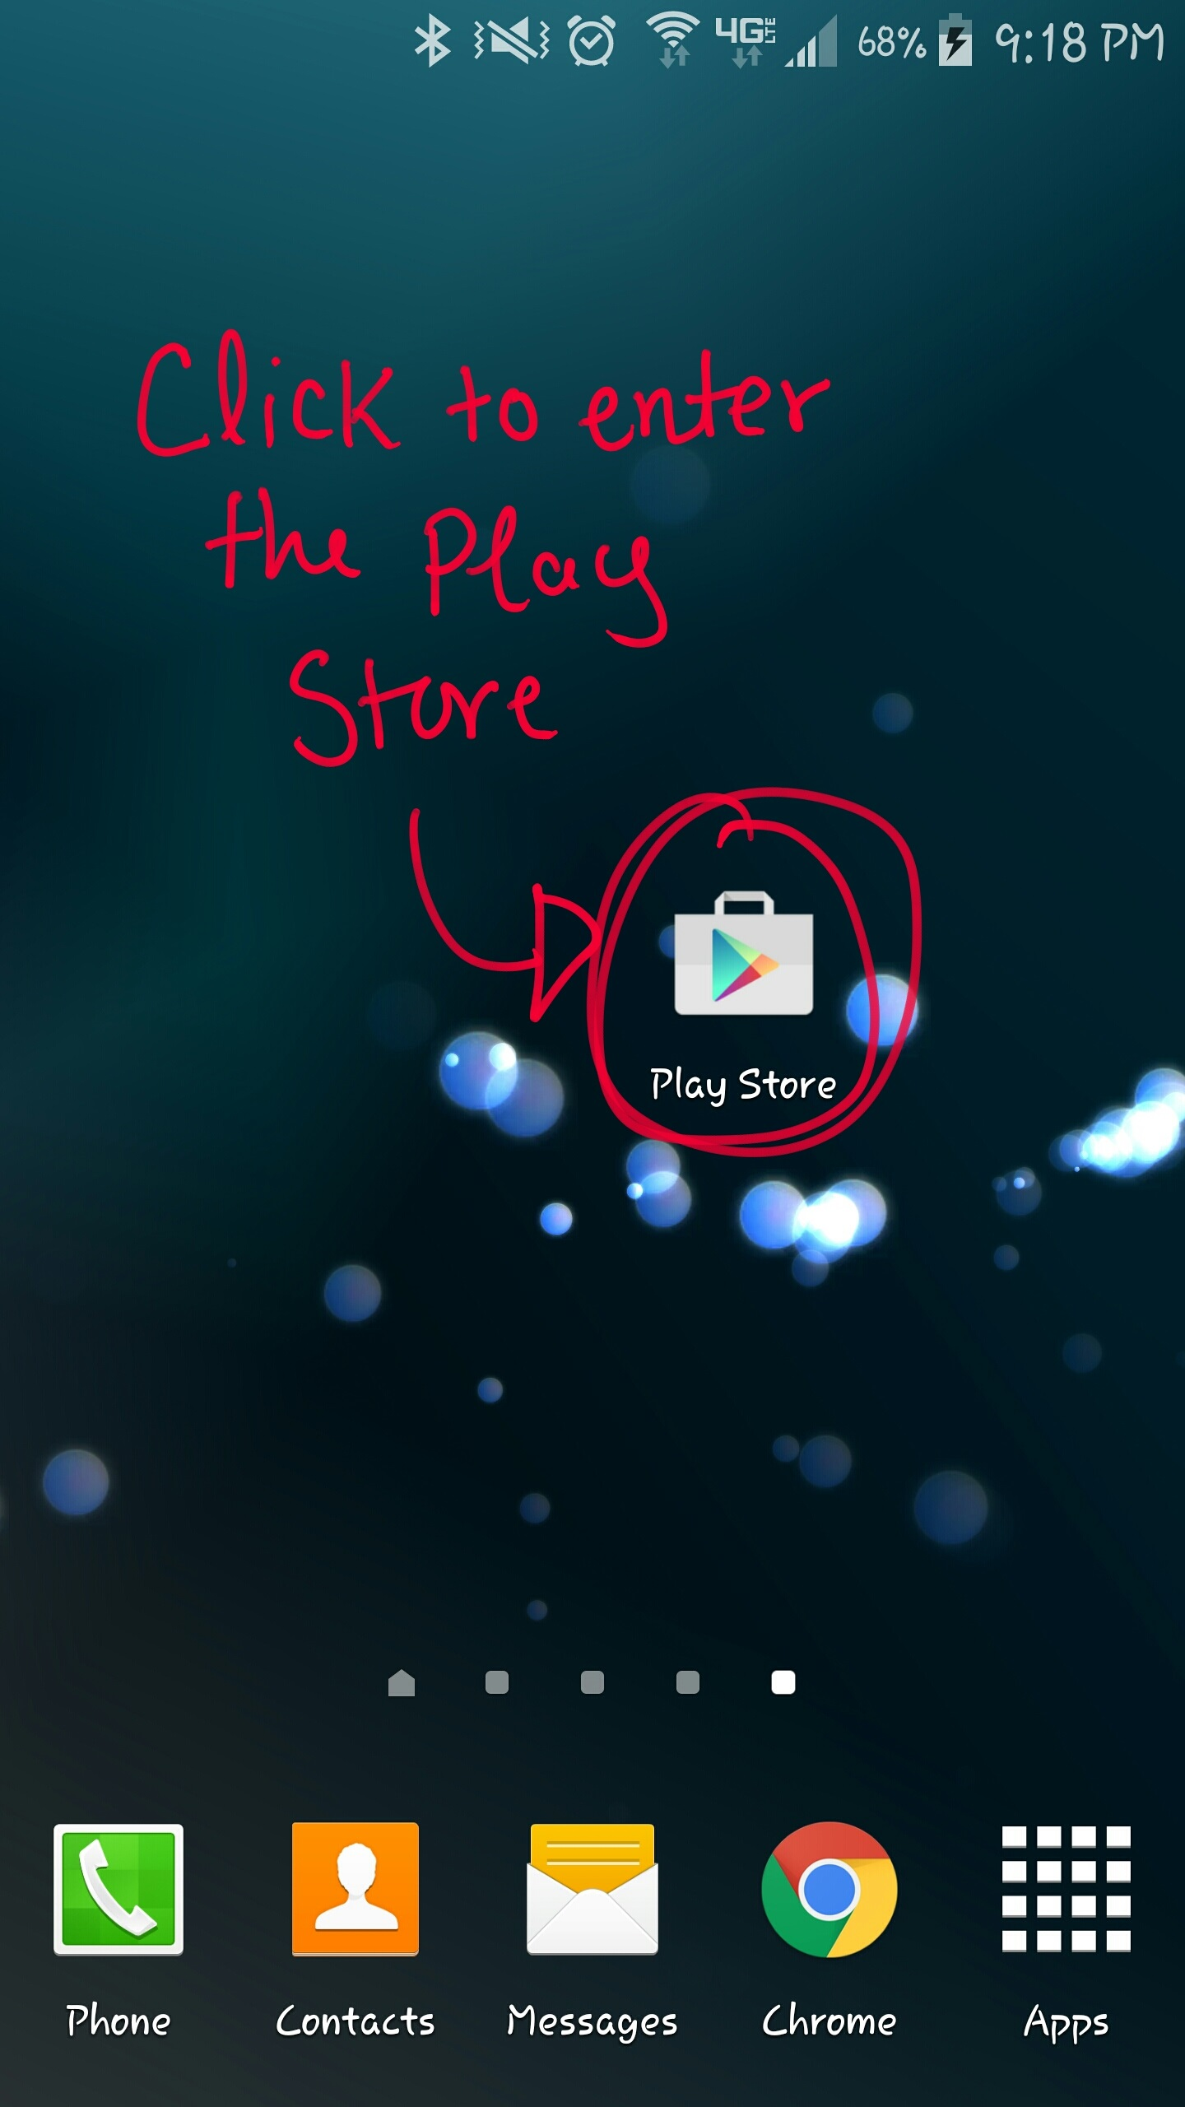

Image 1: Google Play Store Icon

**Step 2.** After entering the Play Store, type in “Kutztown Project Management” in the search bar shown in image 2 or click on the link down below to be directed to the application.

Link: <https://play.google.com/store/apps/details?id=com.kutztown.project.projectmanagement>

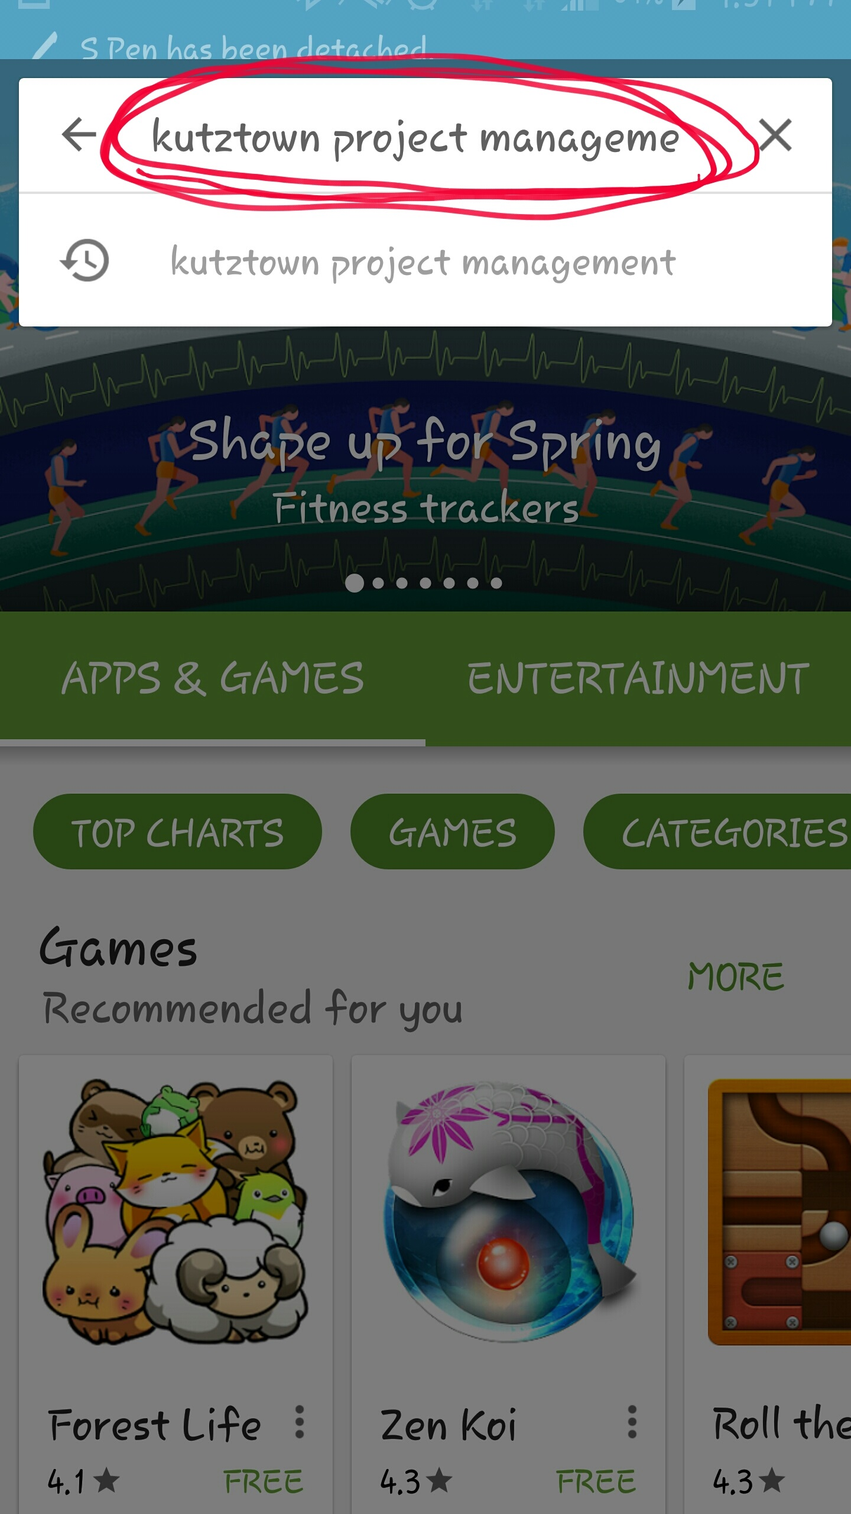

Image 2: Search Bar containing “Kutztown Project Management”

The application’s Icon has the letters “PM” in white with a blue background shown in image 3

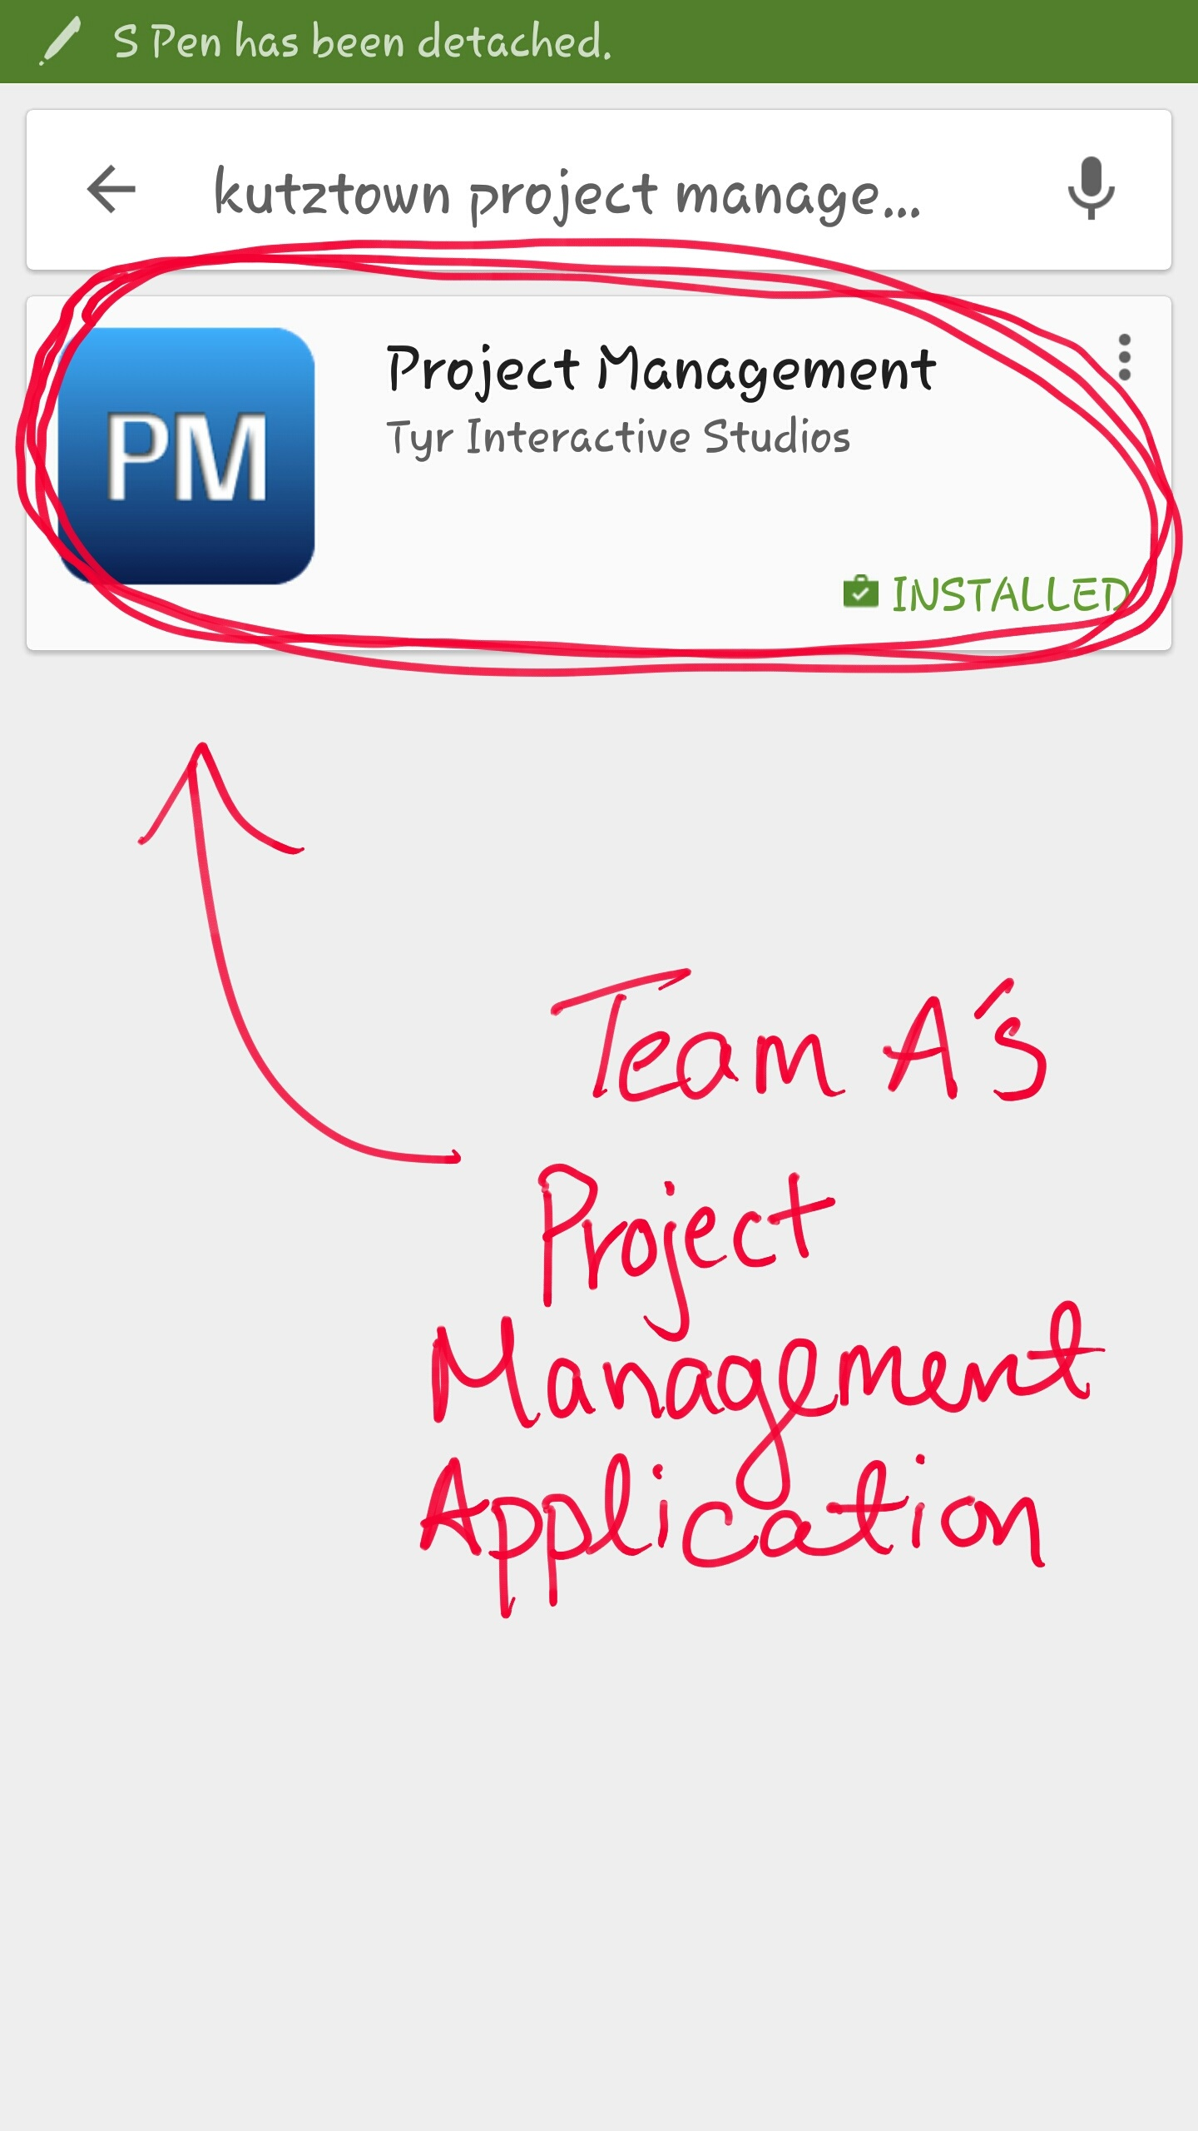

Image 3: Project Management Icon

**Step 3.** Select the Project Management application. You will be directed to the application’s installation page. Click the “INSTALL” button as shown in image 4.

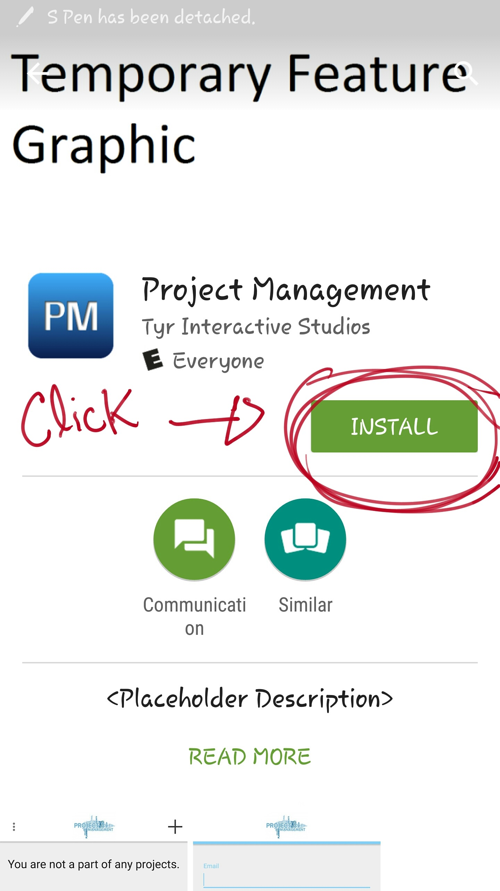

Image 4: Installation button on the application’s installation page

**Step 4.** Accept all of the application’s needs to access and wait for the application to install on your android device. Once the application has properly installed, click the “OPEN” button shown in image 5.

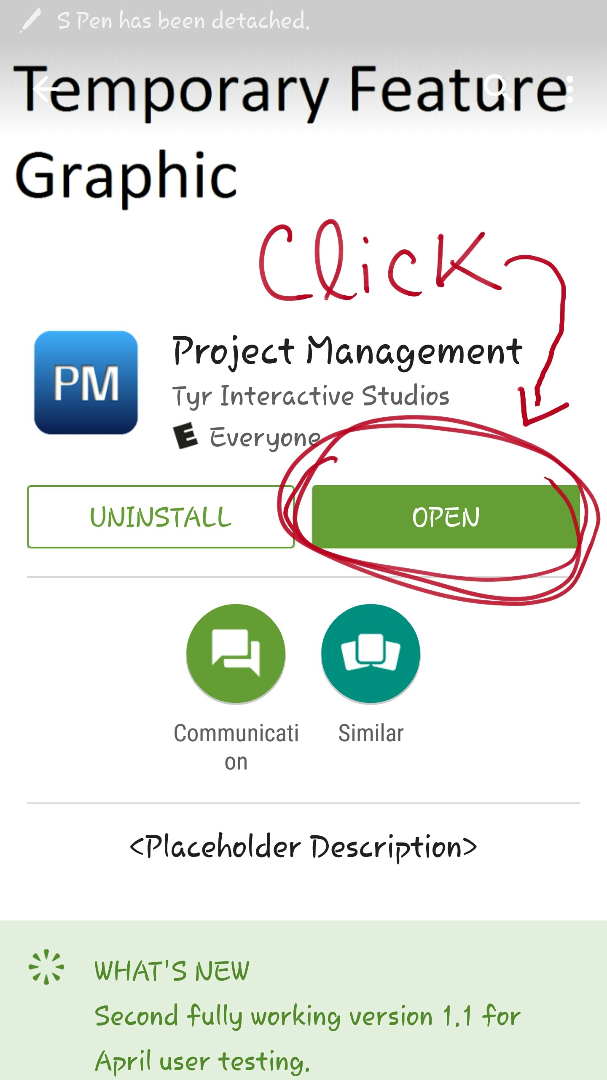

Image 5: Open button is available only after proper installation

Congratulations! You have successfully installed Team A’s Project Management application!

**3.0**